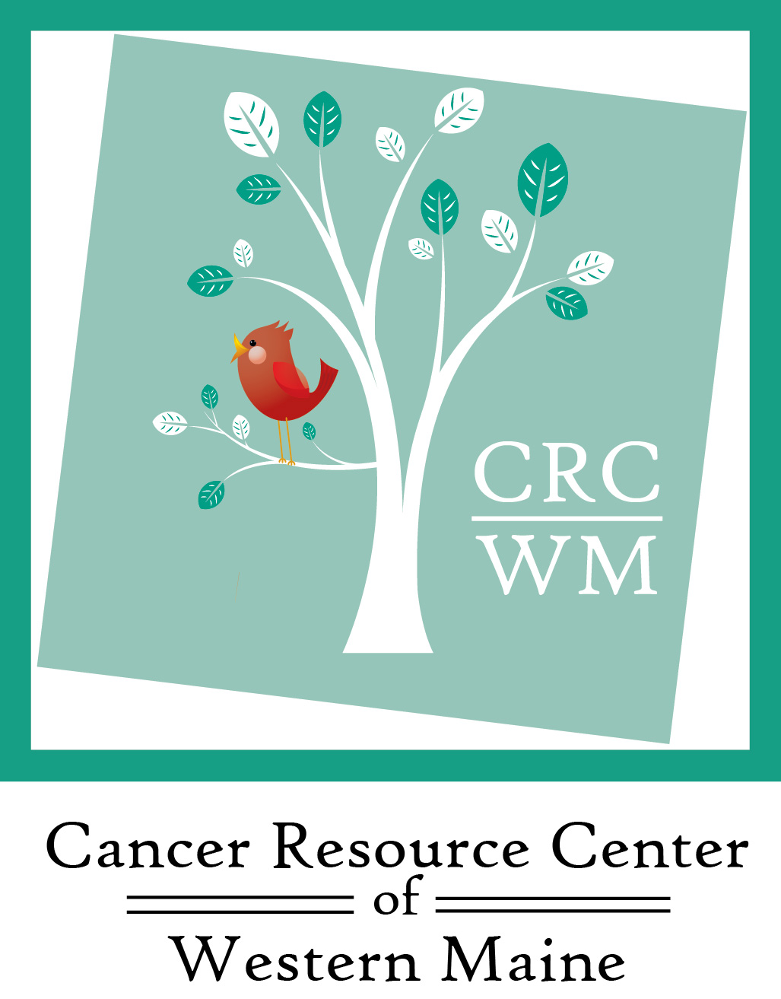
Tee Off for Hope
September 9, 2022
Paris Hill Country Club

Registration/Lunch - 11:30 am
Shotgun start - 12:30 pm

The Cancer Resource Center is a 501c3 non-profit organization which provides a network of support, free wellness programs, travel assistance, wigs and a variety of comfort items to individuals and families impacted by cancer.

Sponsorship Opportunities
(please make a check mark beside choice)

___Gold Sponsor………………………………………………………………………………………$1,500

___Silver Sponsor…………………………………………………………………………………….$1,000

___Bronze Sponsor……………………………………………………………………………………$500

___Hole Sponsor……………………………………………………………………………………….$100

___Team of 4 players only…………………………………………………………………………$400

___Other sponsor opportunity _______________________________________

___Can’t play? Your tax-deductible donation to Tee Off for Hope is welcome and appreciated!
Enclosed is my donation of $ _________
***********************************************************************************

Name/Company__________________________________________________________________

Company Contact (if applicable)______________________________________________________

Email____________________________________Phone___________________________________

Address__________________________________________________________________________

City/Town_____________________________State_________Zip____________

***********************************************************************************
Payment Options:
___Check Enclosed Please make checks payable to: Cancer Resource Center of Western Maine

___Credit Card (please circle) Visa Mastercard Discover

Today’s Date: __ __ /__ __

Credit card # __ __ __ __ __ __ __ __ __ __ __ __ __ __ __ __ __

Exp. Date __ __/__ __ 3 digit code __ __ __ Signature ___________________________________

Tee Off for Hope
September 9, 2022
Paris Hill Country Club

Registration/lunch begins at 11:30 am
Shotgun start – 12:30 pm

Team Name:______________________________________________________

Players:
- Name___________________________________

Email___________________________________

Handicap__________

- Name___________________________________

Email____________________________________

Handicap__________

- Name___________________________________

Email____________________________________

Handicap__________

- Name___________________________________

Email____________________________________

Handicap__________

Please mail form to: Cancer Resource Center of Western Maine, P.O. Box 263, Norway, ME. 04268

Questions? Please call Diane Madden at (207) 890-0329
or email: dmadden@crcofwm.org

