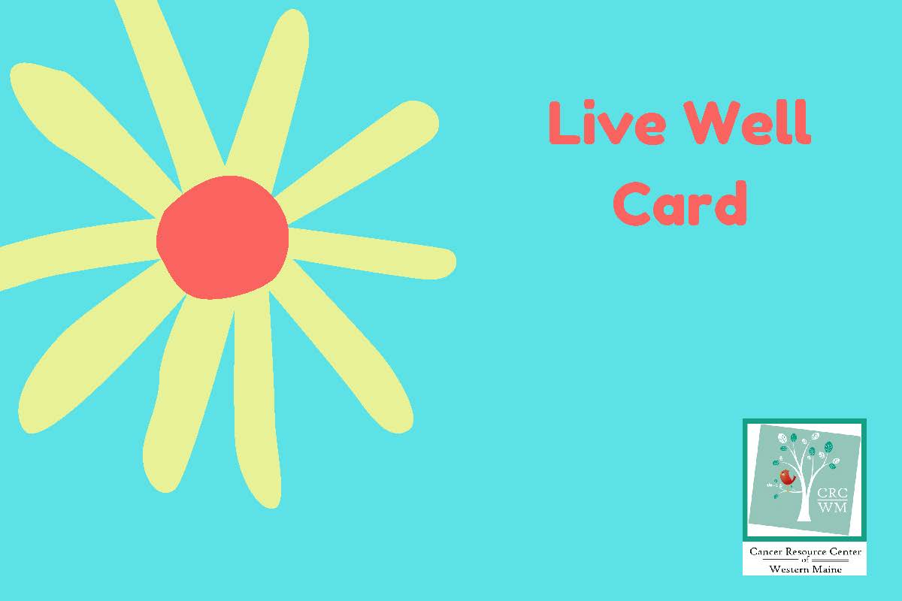
**You may use your Live Well Card for 4 sessions in 2022**
Please give 24hr notice if you need to cancel your appointment
Participating Wellness Providers

Oncology Massage
Nel Andrew Bernard
180 Main St
Norway, ME
handsbreadth@people.com
207-312-9955

Jessica Blasi
154 Main Street
Bridgton, ME. 04009. OR
Justlovelifemassage@gmail.com
603-731-8938

Cedric Mason
452 North Raymond Road
Poland, ME. 04274
(207)653-8181
cedricmmason@gmail.com

Erin Mitchell
14 Main St.
Bethel, ME. 04217
theintegrativebody@gmail.com
(508) 237-2513

Karen Vasil-Busch
100 Back Bryant Road
Buckfield, ME 04220-4109
(207) 336-2065
karenvasilbusch@gmail.com
www.karenvasilbusch.com

Reiki
Nel Andrew Bernard
180 Main St
Norway, ME
handsbreadth@people.com
207-312-9955

Susan Kane M. Ed.
180 Main St.
Norway ME
susan@inlighttransformation.com

Charlotte LaBelle
180 Main St
Norway, ME
teresia@megalink.net
207-890-2177

Christopher Easton
763 Mill Hill Rd
Waterford, ME 04088
207-329-7854 leave message

Paula Easton
763 Mill Hill Rd
Waterford, ME 04088
207-583-6603 leave message

Erin Mitchell (Bethel area)
566 Howe Hill Road
Greenwood, ME. 04255
theintegrativebody@gmail.com
(508) 237-2513

Jessica Carrier
1162 Auburn Road
Peru, ME 04290
Jess.e.carrier@roadrunner.com
(207) 739 -9811

Reflexology
Bonnie Van Durme
29 Main St,, Suite 2
Norway, ME. 04268
vandurme1976@gmail.com
207-890-3200

Karen Tibbetts
footpathreflexology@gmail.com
207-890-1633

Jo-Ann Korhonen
192 Skills Rd.
Bethel, ME 04217
Soultosoul17@gmail.com
207-381-0041

Nutrition Consultation

Jessica Blasi
154 Main Street
Bridgton, ME. 04009
Justlovelifemassage@gmail.com
(603) 731-8938

Life Force Yoga
(individual)

Kat Larsen
15 Tannery St
Norway ME
yogakatboston@hotmail.com
www.katlarsen.com
H 207-809-1257
C 617-216-4911

Somatic Movement Therapy

Kathryn Gardner
PO Box 125
Oxford, ME. 04270
kathryngardner13@gmail.com
C 207-890-7823

Aroma Touch

Trish Grinnell
1109 Naples Road
Harrison, ME 04040
Empoweredlifebydesign@gmail.com
www.empoweredbeauty.studio
C 207-595-8768

_____________________________

Other Opportunities to Use Your Live Well Card

Erin Girzone
Good Health is a Habit Studio
683 Waterford Road
Waterford, ME 04088
Goodhealthisahabit.com
(860) 235-3650

- Redeem one Live Well Card session for a 4-class pass to the following weekly or monthly classes:
- Chair Yoga
- Gentle Flow Yoga
- Yoga Nidra

- Redeem one Live Well Card session for a private session including:
- Somatic Movement Consultation

Private Health & Wellness Coaching Session

Barbara Perry, RN
Certified Health & Wellness Coach – specializing in Oncology Wellness
C (207) 939-5599

